**产品规格承认书**

**PRODUCT SPECIFICATION**

**CUSTOMER 客户名称： 三鼎中天**

**PRODUCT NAME 产品名称： AC BRUSHLESS FAN**

**DIMENSIONS 产品尺寸： 120mm*120mm*38mm**

**MODEL 产品型号： DP22123HBL-AA35**

**DATE 发布日期： 2016. 07.08**

|  |  |
| --- | --- |
| **Checked 审核** | **Prepared 制作** |
|  |  |
| **Customer Approve 客户核准** | |
|  |  |

|  |  |  |  |
| --- | --- | --- | --- |
|  | | | |
|  | |  |  |
| ***DONG GUAN DUAN DU ELECTRONIC CO., LTD.*** | |  |  |
| **TEL： -** |  |  |  |
| **FAX：-** |  |  |  |

**1.General Specification**

|  |  |  |  |
| --- | --- | --- | --- |
| Item | Description | Condition | |
| 1-1. Dimension | 120*120*38mm |  | |
| 1-2. Bearing Type | Two Ball Bearing |  | |
| 1-3. Rated Voltage | AC 220V |  | |
| 1-4. Operating Frequency | 50~400Hz |  | |
| 1-5. Operating Voltage | AC 150-240V |  | |
| 1-6. Start-up Voltage(ON/OFF) | ≦150V | 25℃ Power ON/OFF | |
| 1-7 Rated Current | -- -- | A.At Rated Voltage  B.25℃  C.65%RH  D.Measured after 5minutes | |
| 1-8.Rated Power | 11.3(Max:15.0）W |
| 1-9. Rated Speed | 3500rpm/min±10% |
| 1-10. Max. Air Flow | 145.88( Min:131.29)CFM | 1. PQ Measurement Apparatus 2. Standard: AMCA 3. Rated Voltage 4. Rated Current | |
| 4.13( Min: 3.71m3/min ) |
| 1-11. Max.Static Pressure | 13.92( Min:11.27)mm-H2O |
| 0.55(Min:0.44)inch-H2O |
| 1-12. Noise level | 49.0(Max:52.0)dBA | 1. Rated Voltage 2. Mute Room 3. Distance:1M 4. Background Noise: <18dB | |
| 1-13. Life Expectance | 50000hrs at 40℃ | L10 Failure Criteria:  A.Speed:Under15% of original value  B.Current:Over15% of original value  C. Fan not run | |
| 1-14. Pole | 4 Poles | | |
| 1-15. Rating Direction | Anticlockwise | | |
| 1-16. Other Features | Tachometer Output | | FG |
| Lock Rotor Alarm | | RD |
| LD Rotor Alarm | | LD |
| Auto start | | AS |
| Soft Start | | SS |
| Speed Control Mode | | PWM  VC  TC |
| Waterproof level | |  |

**2.Electrical Specification**

|  |  |
| --- | --- |
| Item | Condition |
| 2-1. Locked Rotor Protection | Safety Condition |
| Auto power off after locked at rated voltage for 1-3sec. And then circuit attempt to restart in 2 to 6 sec，There is no damage after 72hours locking。 |
| 2-2. Polarity Protection | Open circuit when Vcc&GND are exchanged |
| Circuit won't be burned within 5seconds when Vcc&GND are exchanged |
| 2-3. Insulation Resistance | At least 10MΩ at 500 VDC between housing and both lead wires |
| 2-4. Dielectric strength | Withstand 500 VAC 1 minute 1mA between housing and both lead wires |

**3.Specification of Main Material**

|  |  |
| --- | --- |
| 3-1. Frame | PBT UL94V-0 |
| 3-2. Propeller | PBT UL94V-0 |
| 3-3. Bobbin | PBT UL94V-0 |
| 3-4. out of frame Lead wires | UL 1007 22AWG, 300±10mm（Not Contain Connector） |
| 3-5. Connector | NO |
| 3-6 Label Marking | Model No：DP22123HBL.AA35  Rated Voltage：AC 220V  Dissipated Power： 15W |

**4.Environmental Specification**

|  |  |
| --- | --- |
| Item | Condition |
| 4-1.Operating Temperature/Humidity Range | Temperature: -10~+70℃ |
| Humidity :15%~90%RH |
| 4-2. Storage Temperature/Humidity Range | Temperature: -20~+85℃ |
| Humidity :15%~90%RH |

**5. P-Q Characteristic curve test：**

|  |  |
| --- | --- |
| Test conditions and methods | |
| Testing Method ： Constant Voltage | |
| Barometric Pressure：752.4 mmHg | At Rated Voltage |
| Relative Humidity：66.825% | Temperature：25°C |
| test data ： Max Ps :13.92mmAq Max Flow Rate :145.88CFM | |

**P-Q Curve**

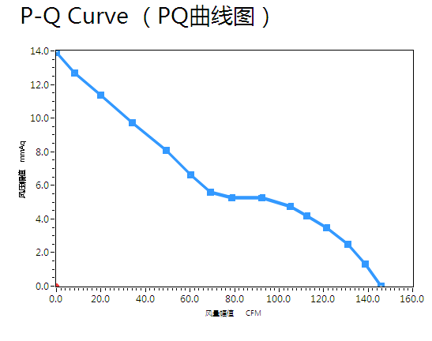

**6. 噪音测试Noise Test**

|  |  |
| --- | --- |
| 测试条件 Test Condition | 测试方法 Test Method |
| 1. 温度 Temperature： 26 ℃ | 1. 测试位置Test Postion：180º |
| 2. 湿度 Humidity： 62 %RH | 2.测试距离 Test Distance：1.0M From the fan intake |
| 3. 在额定电压下At Rated Voltage |
| 4. 在额定转速下 At Rated Speed | 3. 背景噪音Background Noise：14.8dB(A) |
|  | 4. 测试依照标准 ISO3745执行This test executes to ISO3745 standard |
| 测试设备Test Equipment：  AW6290 双通道噪音频谱分析仪 AWA6290M double channels Acoustic Analyzer | |
| 测试结果Test Result： 噪音 Leq：48.2dB(A) | |

6-1. 噪音测试方法示意图 Schematic diagram of noise test method：

DC FAN

6-1. Schematic diagram of noise test method：

DC FAN

MICROPHONE

1M

The direction of the wind

**7.** **Shape** **Drawing**

|  |
| --- |
|  |

**8.Note:**

8.1. We will not guarantee the products if the application of our products are exceeded the limitation which is specified on this specification.

8.2. In case of changes of the specification specified on this document.A written notice is requested in advance.

8.3. Please do not touch the impeller with the pressure and never bring the fan with lead wire.The bearing and lead wire may be damaged.

8.4. No guarantee on the products against the safety problem or failure caused by powder dust, drop of water or insect.

8.5. If there is any data or related documentation different from this data sheet.This data sheet is the principle reference.

8.6. Please do not use the fan in the environment of corrosive gas or liquid or any detrimental gas.

8.7. During the installation of the fan, please pay substantial attention to possible notice caused by resonance vibration and shock.

8.8. It is very important to notify that avoid to drop from 60cm height when in any movement or operation,it will impact the balance of blade. Especially ball bearing structure is avoided to drop down.

8.9. The torque of the screw which locked the frame should not exceed 4 Kgf.

8.10. Please don’t touch the blade when the fan at full speed running , be careful your fingers!